NDP Key Terminology

Background

It has been determined that it is necessary for the NDP to prepare a guideline to ensure a clear and common understanding of key terminology relevant to the Grant. This document presents a list of key terms applicable to the NDPG to ensure alignment and prevent ambiguity amongst NDPG Municipalities and other stakeholders and to harmonize grant management arrangements.

Key Terminology

The key NDPG terminology is presented below:

Strategic/ Planning Terminology
The following terminology should be read within the context of the diagram below:

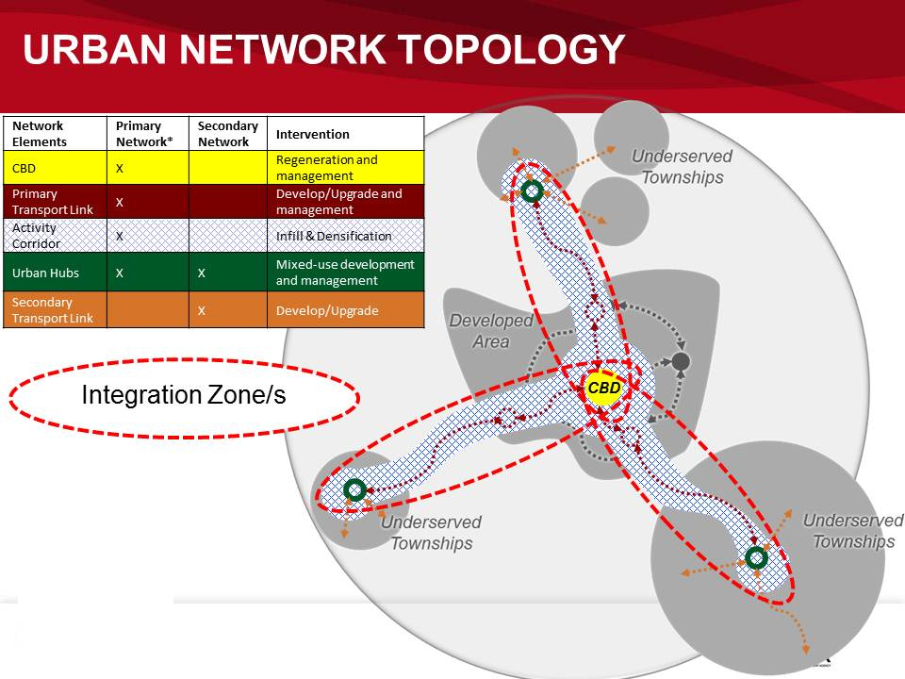

TERM | MEANING
URBAN NETWORKS STRATEGY | The Urban Networks Strategy is a transit oriented investment planning, development and management approach. Its focus is on strategic spatial transformation that optimises access to social and economic opportunities for all and especially the poor.  It aims to work towards a more efficient urban environment that creates an enabling environment for economic growth and development.
URBAN NETWORK | The Urban Network consists of a primary and secondary network which interconnect at strategic nodes known as Urban Hubs, which are located within townships.
PRIMARY NETWORK | The Primary Network is at city-wide scale and consists of anchor nodes, i.e. the CBD, a number of Urban Hubs, Public Transport Links and Activity Corridors between these anchor nodes.
INTEGRATION ZONE | The Primary Network consists of a number of Integration Zones. Each zone consists of one Urban Hub, a Transport Link and Activity Corridor as well as the CBD.
CBD | The CBD is the central business district of the city region and the centre of the urban network. For the purpose of the Urban Networks strategy, the main focus of the CBD is on public transport modal facilities.
URBAN HUB | Urban Hubs refer to a small number of new regional nodes located in strategic areas within townships. They will function as “town centres” for the surrounding township or cluster of townships and will provide access to the rest of the wider urban area. It will be planned and developed as a high density, mixed use precinct that contains a diverse variety of land uses, services and activities.  At the core of the Urban Hub is an efficient intermodal public transport facility and a system of public spaces and walkways where people can experience a diverse range of activities. Land uses such as retail, recreation, offices, banking, community facilities and government services, hospitality/tourism, leisure and high density housing are located around the core within an urban design framework that promotes a vibrant sense of place in which to live, work and play.  Refer to the Urban Hub Design Methodology Toolkit for more detail.
ACTIVITY CORRIDOR | The Activity Corridor is located between the CBD and an Urban Hub and consists of a belt of land approximately 2 km wide adjacent to a Primary Public Transport link with a number of corridor nodes [established and emerging] along the corridor.
EXISTING NODES | Existing nodes are well located regional mixed use activity centres.
SECONDARY NODES | Secondary Nodes are strategically located mixed use nodes within township areas and are directly linked to the Urban Hub by means of a prioritised public transport link such as taxi, bus or train route.
EMERGING CORRIDOR NODES | Secondary nodes can also be located on the Activity Corridor between the CBD and the Urban Hub. These secondary nodes are known as Emerging Corridor Nodes.
SECONDARY NETWORK | The network at the scale of the township or a cluster of townships. It includes the Urban Hub and a number of Secondary Nodes as well as Secondary Transport Linkages between these nodes.
FUNCTIONAL AREA | A functional area is a dense built up area that presents a concentration of people, activity, capital and buildings and is structured on major roads, railroads and terminals. It forms a system that functions by flows of people, goods, energy, information and money and includes a contiguous core of urban areas and commuters belts from which a fixed percentage of commuting to work is directed mainly within the functional area.

2.2 Operational Terminology

TERM | MEANING
NDP OPERATIONS GUIDE | The NDP issued an Operations Guide in 2009 to assist Municipalities with the planning and implementation of the NDPG. The Operations Guide contained the original NDP Toolkit issued in July 2006. The content of the 2009 Operations Guide is replaced by the NDP Urban Networks Support Guide.
URBAN NETWORKS ROAD MAP | The NDP road map or framework to help plan and coordinate the operational steps required by a Municipality to utilise the Grant.
START UP WORK PLAN | A “Start Up” Work Plan is submitted to the NDP to confirm how the Municipality intends to implement the NDP Urban Networks Programme.  The Municipal Work Plan is submitted to NDP during the Planning Phase of the Urban Networks Road Map.  Refer to the Planning Guidance Document for more detail.
EXTENDED WORK PLAN | Expanding on the Start Up Work Plan, this document is submitted by the Municipality [assisted by Service Provider] to the NDP to explain how the Service Provision appointment and key outputs proposed within the Bid Response by appointed Service Providers will be executed within the prescribed timelines.  It is expected that the Municipality will submit updated versions of the Work Plan every six months to confirm progress and cost updates.  Refer to the Planning Guidance Document for more detail.
URBAN NETWORK PLAN | The Urban Network Plan is a critical strategic spatial document identifying, prioritising and planning for Urban Network Elements for a specific municipal area as proposed within the Urban Networks Strategy.  The Urban Network Plan prepares the Municipality for the development of Precinct Plans addressing local planning and the prioritisation of projects within the CBD, Urban Hubs and Activity Corridors in underserved/ previously disadvantaged areas.  There will be one Urban Network Plan per Municipality for submission to the NDP Unit for approval. The Municipality should utilise the TA/ICDG funds available to develop an Urban Network Plan. The Urban Network Plan is submitted to NDP during the Planning Phase of the Urban Networks Road Map.  Note that an Urban Network Plan is not a Business Plan as referred to in previous NDP guidance documents.  Refer to the Planning Guideline for more detail.
PRECINCT PLAN | A Precinct Plan is a document detailing the plan for the development of an Urban Hub, Activity Corridor or CBD.  For the purpose of this document the Precinct Plan is described in terms of the development of an Urban Hub.  A toolkit with detail on the design methodology for the development of the Urban Hub discussed is available from the [NDP URBAN HUB DESIGN TOOLKIT].  The outcome of a Precinct Plan will be a detailed composition of the future spatial structure of the urban hub by means of a map/s as well as design guidelines. In addition, the Precinct Plan will prepare the Municipality for the submission of prioritised projects for approval by NDP. The Precinct Plan should therefor also contain Project Concept Plans with detail on individual projects.  There may be one or more Precinct Plan/s per Municipality depending on the number of Urban Hubs identified by the Municipality.  The Precinct Plan is submitted to NDP during the Planning Phase of the Urban Networks Road Map. Refer to the Planning Guideline for more detail.
PROJECT | The agreed objective in the Memorandum of Agreement with Municipalities will ultimately culminate in a series of projects that are funded through the CG. These are projects that support the NDPG’s objective of funding public infrastructure, places, facilities and other initiatives that will attract private and community sector investment in urban hubs.
PROJECT PLAN | A Project Plan is submitted by a Municipality to confirm the implementation details of a discrete project. It is viability based and should be supported by:  - Detailed engineering/architectural designs of the project.  - Technical documentation sufficient for council submissions.  - Tender evaluation and approval information.  The transfer of capital funding will only be allowed once a project has been approved and the final submission of tender values has been submitted and approved for go-ahead by NDP.
PRECINCT MANAGEMENT PLAN | A Precinct Management Plan is a tool to optimise the use of existing resources and manage/maintain and improve key activities and priorities within a delineated area to ensure value for money and long term impact.  There may be one or more Precinct Management Plan/s per Municipality depending on the number of Urban Hubs identified by the Municipality.  The Precinct Management Plan is submitted to NDP during the Operations and Management Phase of the Urban Networks Road Map.
CLOSE-OUT REPORT | The Close-Out Report confirms finalisation of a discrete project. The purpose of the Close-Out Report is to:  - Ensure the NDP that project completion was achieved.  - Confirm that the project has been finalised within planned budget and timeframe.  - To confirm whether or not objectives were achieved.  - To outline any events of significance during the project.  - To confirm any unresolved disputes.  - To make suggestions for improvements.  - To confirm that the quality of work is acceptable.  - Confirm that the project history is available (updated project records).  - Hand-over/s in case of construction project component.  The Close-Out Report is submitted to NDP during the Implementation Phase of the Urban Networks Road Map.

2.1 Financial and Administrative

TERM | MEANING
AGREED OBJECTIVE | The agreed objective is referred to in the Memorandum of Agreement and means the shared objective of creating more spatially integrated, vibrant townships and urban areas.
CAPITAL GRANT FUNDING | Funds allocated and transferred by the National Treasury to a Municipality for the payment of Contractors on a Project, provided such Funds are allocated and agreed by the National Treasury, in accordance with both its approval of the Project Plan and approved Municipal Cash Flows.
CASH FLOWS | Submitted by Municipalities to confirm projected monthly spend and milestones achieved over a certain period of time. Submitted on the NDP MIS by Municipalities. Previously known as Milestone Payment Schedules or Schedule 3A documents.
CITIES SUPPORT PROGRAMME (CSP) | The Cities Support Programme (CSP) is an initiative of National Treasury that was announced in the 2012/13 budget. The CSP proposes a systematic approach to create incentives for cities to address the issue of urban spatial form, and specifically to weaken existing incentives that perpetuate the apartheid city, through coordinating funding programmes and linking these to national regulatory reforms in the built environment and specific capacity support measures to assist cities.
DEVELOPMENT INCENTIVES | Development Incentives will be in the form of assistance provided on a discretionary basis by government to attract or retain investment. The goal of development incentives ultimately is to induce growth in targeted areas.
INTEGRATED CITY DEVELOPMENT GRANT  (ICDG) | A new grant for metropolitan municipalities has been introduced in the 2013/14 national budget. The Integrated City Development Grant (ICDG) will provide incentives for participating municipalities who:  - Have defined their urban networks (including all network elements)  - Have put in place a prioritisation of network elements based on spatial development objectives and network optimisation  - Define measureable performance objectives, indicators and targets  The ICDG will:  - Provide a strategic focal point for improved intergovernmental coordination, both within and between spheres of government  - Assist municipalities to plan and programme a series of catalytic investments within the identified urban network that can be funded by existing sources of finance.  - Ensure that catalytic investments in each part of the urban network also ensure the long-term optimization of the entire urban network.  - Reward municipalities for progress with the implementation of catalytic investments and the achievement of pre-specified performance indicators.
LEVERAGE | To attract and increase the level of investment and funding by private sector, NGOs as well as government organisations and the community and to contribute to the creation of an improved investment climate in urban hubs and secondary networks.
MANAGEMENT INFORMATION SYSTEM (MIS) | An IT system used by the NDP Unit to manage Municipal submissions and data.
MEMORANDUM OF AGREEMENT | The agreement between the Municipality and the NDPG to establish a relationship in terms of the NDPG funding. Where a Municipality has already been in a relationship with the NDP this document will replace the existing “funding agreement”.
MONTHLY WEB REPORTS | A report submitted by Municipalities on a monthly basis via the MIS to confirm spend and progress with NDP projects.
TECHNICAL ASSISTANCE FUNDING | Funds allocated by the National Treasury to a Municipality for the payment of Consultants, provided such Funds are allocated and agreed by the National Treasury, and are to be paid, upon receipt of invoices for progress payments verified by the Accounting Officer, in accordance with the approved Municipal Cash Flows.

Integration Zones: applicable to Metro Municipalities only.

